**Industrial Electronics**

**Assignment-1**

Evaluate the performance of the separately excited dc motor using phase controlled semi-converter and full converter. The motor parameters are:

DC Motor: 110 V, 1800 RPM, Torque = 10N.m, 25HP, Ra = 0.6 Ω and La = 6mH.

**M-code:**

% Industrial Electronics Assignment

% Sambhav R Jain

% 107108103

clc;

clear all;

close all;

fprintf('Performance Analysis of a single phase separately excited DC motor drive - Analytical Solution\n');

fprintf(' - Sambhav R Jain (107108103)\n\n');

% fprintf('Enter the following parameters:\n');

% V = input('Supply rms voltage (V): ');

% Ra = input('Enter the armature resistance (Ohm): ');

% La = input('Enter the armature inductance (Henry): ');

% f = input('Enter the supply frequency (Hz): ');

% del_i = input('Enter the maximum current error (A): ');

% del_alpha = input('Enter the incremental alpha (deg): ');

% alpha_max = input('Enter the maximum firing angle (deg): ');

V = 110;

Ra = 0.6;

La = 6e-3;

f = 50;

del_i = 0.001;

del_alpha = deg2rad(15);

alpha_max = deg2rad(150);

Vm = sqrt(2)*V;

w = 2*pi*f;

Z = sqrt(Ra^2 + (w*La)^2);

theta_z = atan(w*La/Ra);

alpha = 0;

alpha = deg2rad(alpha);

N = 1;

while 1

Eg = Vm*N;

if(Eg < Vm*sin(alpha))

if(alpha < pi/2)

break

end

end

N = N - 0.0001;

end

theta_s = max(alpha,asin(Eg/Vm));

Ia_s = 0;

% A1 = (Ia_s - (Vm/Z)*sin(theta_s-theta_z) + Eg/Ra)*exp(Ra/(w*La)*theta_s);

Ia_pi = Vm/Z*(sin(pi-theta_z) - sin(theta_s-theta_z)*exp(Ra/(w*La)*(theta_s-pi))) + Eg/Ra*(exp(Ra/(w*La)*(theta_s-pi))-1) + Ia_s*exp(Ra/(w*La)*(theta_s-pi))

% A2 = (Ia_pi+Eg/Ra)*exp(Ra/w*La*pi);

ch = menu('Choose:','Semi-converter','Full-converter');

if ch == 1

Ia_pi_alpha = Ia_pi*exp(Ra/(w*La)*(pi-pi-alpha)) + Eg/Ra*(exp(Ra/(w*La)*(pi-pi-alpha))-1)

Ia_pi_theta_s = Ia_pi*exp(Ra/(w*La)*(pi-pi-theta_s)) + Eg/Ra*(exp(Ra/(w*La)*(pi-pi-theta_s))-1)

end

if ch == 2

Ia_pi_alpha = Vm/Z*(sin(pi+alpha-theta_z) - sin(theta_s-theta_z)*exp(Ra/(w*La)*(theta_s-pi-alpha))) + Eg/Ra*(exp(Ra/(w*La)*(theta_s-pi-alpha))-1) + Ia_s*exp(Ra/(w*La)*(theta_s-pi-alpha))

Ia_pi_theta_s = Vm/Z*(sin(pi+theta_s-theta_z) - sin(theta_s-theta_z)*exp(Ra/(w*La)*(theta_s-pi-theta_s))) + Eg/Ra*(exp(Ra/(w*La)*(theta_s-pi-theta_s))-1) + Ia_s*exp(Ra/(w*La)*(theta_s-pi-theta_s))

end

if Ia_pi_alpha > 0

if Ia_pi_theta_s > 0

theta_s = alpha;

while 1

Ia_s = Ia_pi_alpha;

% A1 = (Ia_s - (Vm/Z)*sin(theta_s-theta_z) + Eg/Ra)*exp(Ra/(w*La)*theta_s);

Ia_pi = Vm/Z*(sin(pi-theta_z) - sin(theta_s-theta_z)*exp(Ra/(w*La)*(theta_s-pi))) + Eg/Ra*(exp(Ra/(w*La)*(theta_s-pi))-1) + Ia_s*exp(Ra/(w*La)*(theta_s-pi))

% A2 = (Ia_pi+Eg/Ra)*exp(Ra/w*La*pi);

I_old = Ia_pi_alpha;

% ch = menu('Choose:','Semi-converter','Full-converter');

if ch == 1

Ia_pi_alpha = Ia_pi*exp(Ra/(w*La)*(pi-pi-alpha)) + Eg/Ra*(exp(Ra/(w*La)*(pi-pi-alpha))-1)

Ia_pi_theta_s = Ia_pi*exp(Ra/(w*La)*(pi-pi-theta_s)) + Eg/Ra*(exp(Ra/(w*La)*(pi-pi-theta_s))-1)

end

if ch == 2

Ia_pi_alpha = Vm/Z*(sin(pi+alpha-theta_z) - sin(theta_s-theta_z)*exp(Ra/(w*La)*(theta_s-pi-alpha))) + Eg/Ra*(exp(Ra/(w*La)*(theta_s-pi-alpha))-1) + Ia_s*exp(Ra/(w*La)*(theta_s-pi-alpha))

Ia_pi_theta_s = Vm/Z*(sin(pi+theta_s-theta_z) - sin(theta_s-theta_z)*exp(Ra/(w*La)*(theta_s-pi-theta_s))) + Eg/Ra*(exp(Ra/(w*La)*(theta_s-pi-theta_s))-1) + Ia_s*exp(Ra/(w*La)*(theta_s-pi-theta_s))

end

abs(I_old - Ia_pi_alpha)

if abs(I_old - Ia_pi_alpha) <= del_i

break

end

end

end

end

**Characteristics:**

1. **Semiconverter**

% Sambhav R Jain (107108103)

clc;

clear all;

close all;

V = input('Enter the rms voltage: ');

k_phi = input('Enter the field constant: ');

Ra = input('Enter the armature resistance: ');

td = 0:0.01:20;

Vm = sqrt(2)*V;

for a=0:30:150

Va = Vm/pi*(1+cosd(a));

w = Va/k_phi - td*Ra/k_phi^2;

plot(td,w);

xlabel('Torque(N-m) ---->'); ylabel('Speed (rad/s) ---->'); title('Speed torque for a separately excited dc motor for different firing angles');

% legend(sprintf('alpha = %d',a));

hold on

grid

end

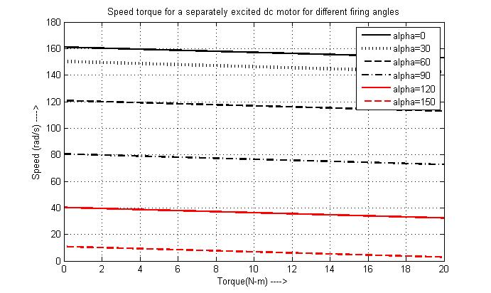**Speed-Torque Plot:**

1. **Full converter**

% Sambhav R Jain (107108103)

clc;

clear all;

close all;

V = input('Enter the rms voltage: ');

k_phi = input('Enter the field constant: ');

Ra = input('Enter the armature resistance: ');

td = 0:0.01:20;

Vm = sqrt(2)*V;

for a=0:30:150

Va = 2*Vm/pi*(cosd(a));

w = Va/k_phi - td*Ra/k_phi^2;

plot(td,w);

xlabel('Torque(N-m) ---->'); ylabel('Speed (rad/s) ---->'); title('Speed torque for a separately excited dc motor for different firing angles');

% legend(sprintf('alpha = %d',a));

hold on

grid

end

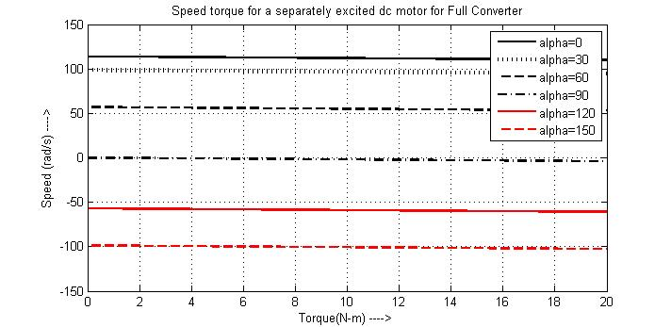**Speed-Torque Plot:**